User Guide 36 Importing your digital certificates into the Windows Certificate Store
Purpose of this Guide
The purpose of this guide is to provide information on how to import your digital certificates into the Windows Certificate Store via the Control Panel. The digital certificates must be installed in the Certificate Store to be able to sign in SPEAR.
NOTE: If your certificates are stored on an eToken, the steps in this user guide are not required.
36.1 How to import your digital certificate
- Locate your back up files containing your digital certificates. Double-click on the first digital certificate file to open the Certificate Import Wizard and click 'Next' to continue.
NOTE: If you receive a Store Location prompt, select Current User.
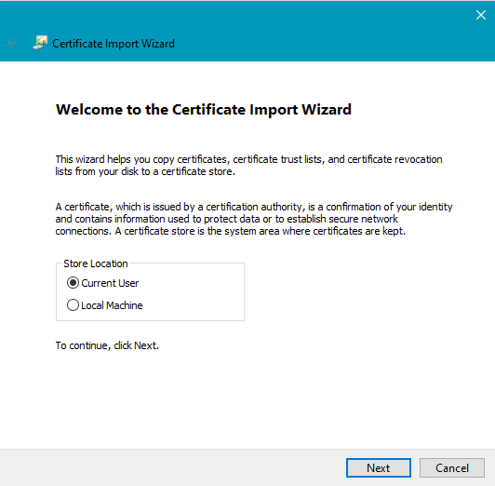
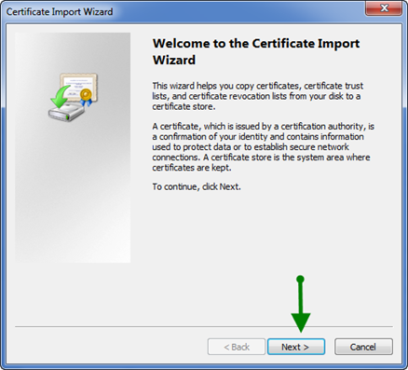

- The File to Import screen is displayed. Click 'Next' to continue.
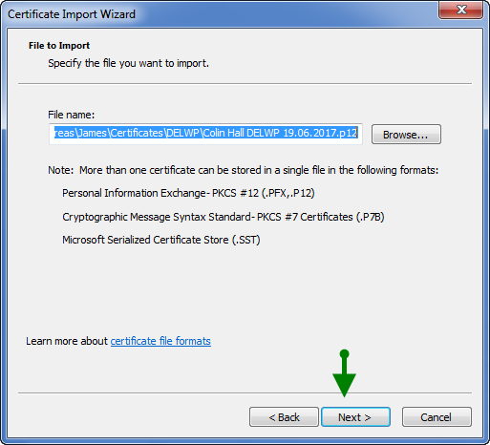

- You will now be prompted to enter your password. Ensure the ‘Enable strong private key protection…’, 'Mark this key as exportable…’ and ‘Include all extended properties’ are checked and click 'Next'.
NOTE: This is the password that you allocated to the certificate when you first downloaded it from Symantec.
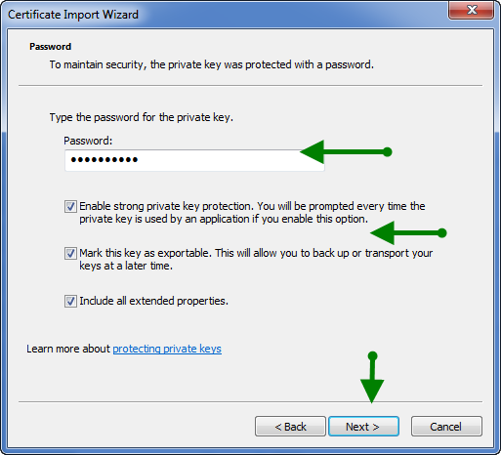

- Select the option ‘Automatically select the certificate store based on the type of certificate’. Click 'Next'.
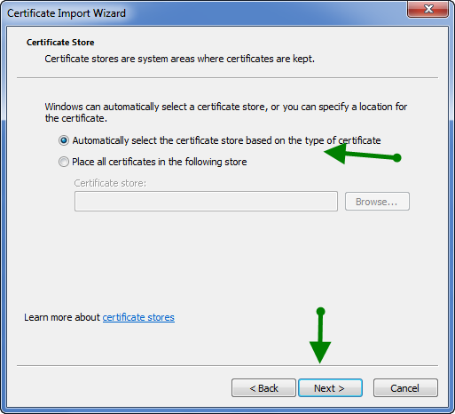

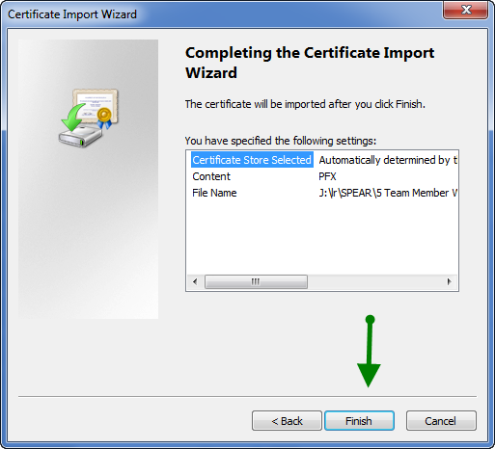
- Click ‘Finish’ to complete the Certificate Import Wizard.

- The ‘Importing a new private exchange key’ window will appear. Click ‘Set Security Level, then select ‘High’. Click ‘Next’ to continue.
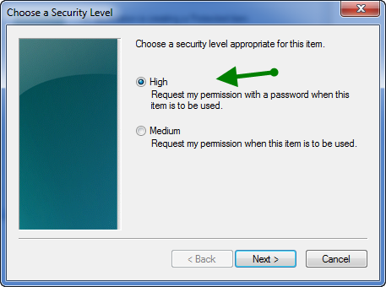
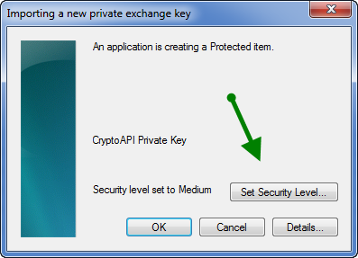

- Enter and confirm a password to be used when signing in SPEAR. It is recommended you use the same password that you previously supplied when importing your certificate.
Click ‘Finish’ and ‘OK’ to complete the import.
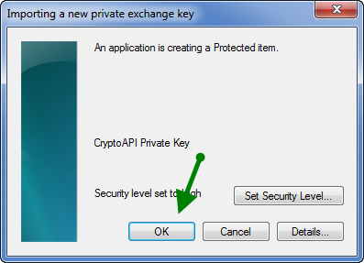
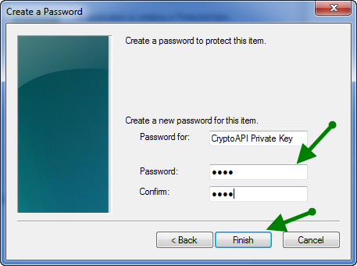

- You will receive a message advising the import was successful. Click 'OK' to close this message.
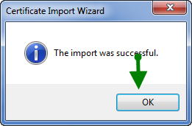

Repeat steps 1 to 9 of this guide to import your second certificate.

36.2 How to check if your certificates are in the Certificate Store
- Open the Windows Control Panel. Depending on your Operating System, this is usually found by clicking ‘Start’ > ‘Settings’ > ‘Control Panel’.
- Locate ‘Internet Options’ from the Control Panel and double-click to open it.
- On the Internet Options screen now displayed, click the Content tab. On the Content screen, click 'Certificates'.
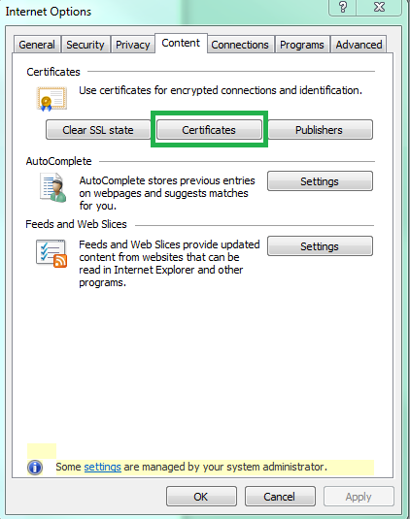

- If there are no digital certificates listed under the Personal tab (there should be two certificates in your name) you will need to click 'Import…' and follow the steps at the start of this guide to import your digital certificates into the Store.
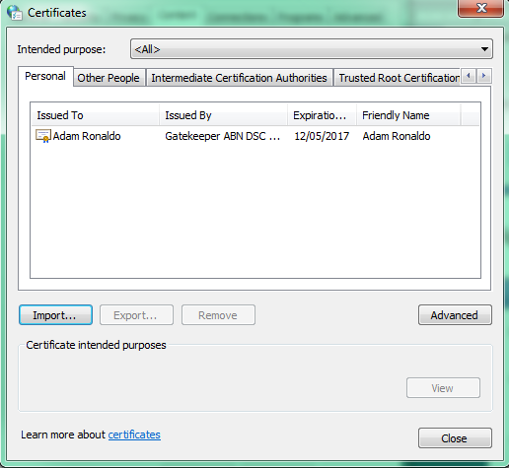

- Once imported, your two certificates should be visible in the Certificates screen.

36.3 What next?
Now that you have imported your digital certificate into the Windows Certificate Store, it needs to be tested. Please see User Guide 34 – Testing your digital certificate for more information.
If you are a Certificate Manager and require assistance with authorising standard digital certificates ordered by other members of your organisation, please refer to User Guide 37 - Certificate Manager guide to approving standard digital certificates.
Need more information?
Further information on this topic can be found by:
- Visiting the SPEAR website www.spear.land.vic.gov.au/SPEAR
- Contacting the SPEAR Service Desk on 9194 0612 or email spear.info@delwp.vic.gov.au

